**PROJECT REPORT TEMPLATE**

**INTRODUCTION**

Business Expenses Explained Also referred to as deductions, business expenses are the costs of operating a business. They're recorded on the income statement. These expenses will be subtracted from business revenue to show a company's net profit or loss and taxable income.

* 1. OVERVIEW
* An expense is a cost that businesses incur in running their operations. Expenses include wages, salaries, maintenance, rent, and depreciation. Expenses are deducted from revenue to arrive at profits. Businesses are allowed to deduct certain expenses from taxes to help alleviate the tax burden and bulk up profits.
* Examples include inventory, payroll and rent. Fixed expenses are regular and don't change much — things like rent and insurance. Variable expenses are expected, but they can change. Some examples include sales commissions, gas for business vehicles and shipping costs. The overview of the project is, it’s very useful to all business. The graph ae explained the business strategy.
  1. PURPOSE
* The Business Purpose provides the justification for the expense and should be written so that someone reading it at a future time would have sufficient information about the activity (for example, provide context, spell out any acronyms, and include full titles and department names) and why it was a permissible Stanford.
* This project is used for business starters to guide a correct way to get a success in their business.

**2** **PROBLEM DEFINITION & DESIGN THINKING**

2.1 EMPATHY MAP

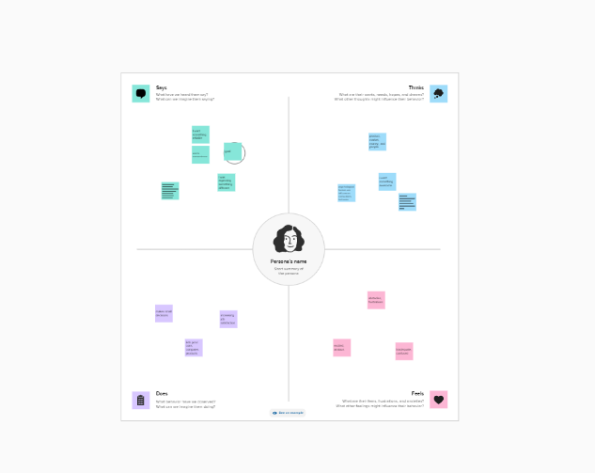

2.2 IDEATION & BRAINSTORMING MAP

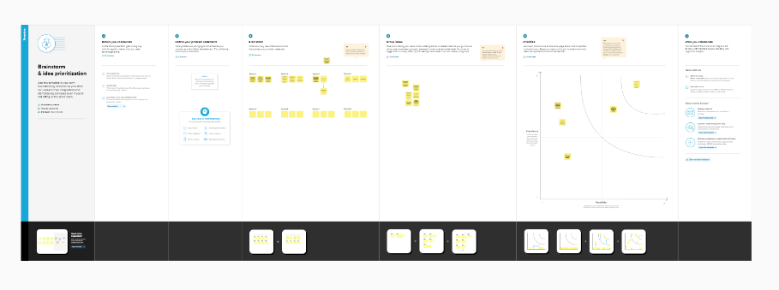

**RESULT**

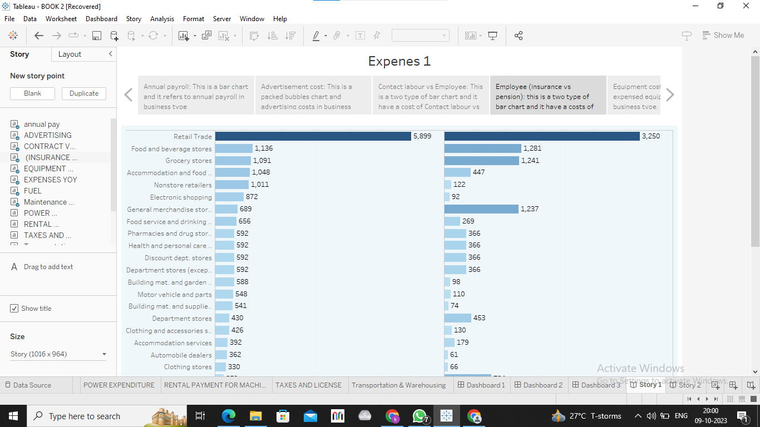

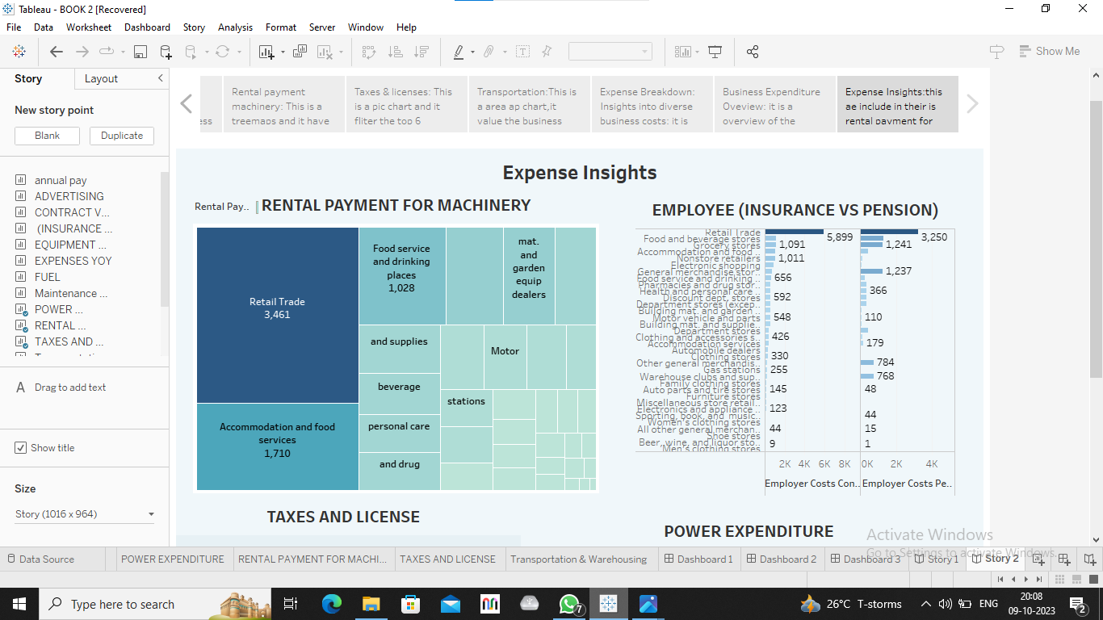

**ADVANTAGES & DISADVANTAGES**

Advantages

* Benefits of Corporate Independence and Control
* Huge Financial Advantages
* Individual Growth, Creative Freedom, and Personal Satisfaction
* Tax Advantages
* Mode of living and freedom

Disadvantages

* Financial risks
* Time commitment
* Dealing with stress
* Risk of failure
* High competition
* Lack of business processes and operational procedures

**APPLICATIONS**

* Expense management software is a type of application that simplifies the receipt-to-reimbursement process by automating much of it. With this software, firms can manage travel bookings, automate expense report submission, streamline approvals, accelerate reimbursements, and track expense claims in real time.
* An expense management process is a set of procedures that helps businesses streamline their spending. It is the sequential flow through which employees make claims for reimbursements and account for the business expenses they incur.

**CONCLUSION**

Efficient expense management is a critical component of financial success for businesses of all sizes. Tracking expenses helps companies gain insights into their spending patterns, adhere to financial regulations, and make informed decisions.

**FUTURE SCOPE**

The data captured by the expense management system in a business helps in budgeting and planning for future expenses. The key functions in expense management are filling in expense requests, reviewing and approval of requests, employee reimbursement, and gathering and validating data for auditing and budgeting.